Object Oriented Programming  
Lab Manual



# Topic: Polymorphism

Faculty of Information Technology

UCP Lahore Pakistan

# Lab Tasks

**Question 1:**

UCP Banking System

Develop a polymorphic banking system using the Account hierarchy. Accounts can be of two types Savings Account and Current Account. For each Account, allow the user to specify an amount of money to withdraw from the Account and an amount of money to deposit into the Account. As you process each Account, determine its type. If an Account is a Savings Account, calculate the amount of interest owed to the Account as per current policy rate, then add the interest to the account balance. After processing an Account, the updated account balance can be displayed when requested.

**Question 2:**

Implement the following class hierarchy. Write a function Area () to calculate area of each object of any

Shape.

**Use Polymorphism**

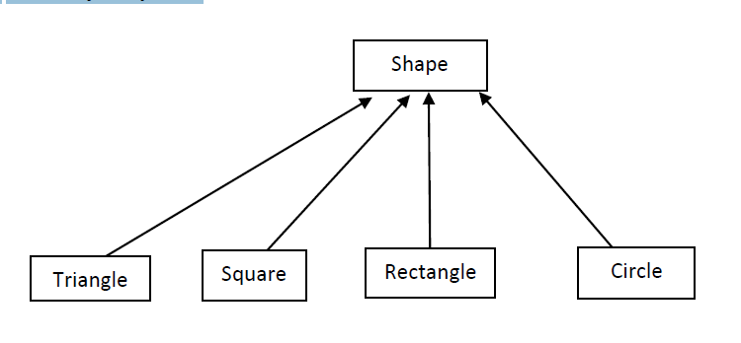

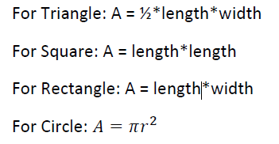

* Select attribute of each class as required above.
* Make Abstract class where needed.
* Make an parameterized constructor that takes parameters required in each class
* Call Area() function of each class through concept of polymorphism.

**Question 3**

You will create a hierarchy of animals that is rooted in an abstract class Animal. Several of the animal classes will implement an abstract class called Pet. The diagram given below is showing the relationship among classes and their attributes. Where type of inheritance is public in each scenario.

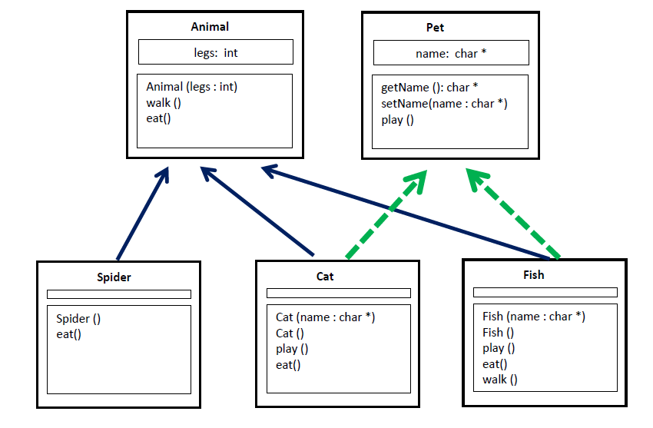

**Explanation**

Animal class has an attribute of type integer (leg). It has a parameterized constructor and two member functions walk() and eat(). Both the functions are not accepting any argument and not returning anything. The arrows in above image, show the inheritance hierarchy. For example: animal class is inherited by Spider, Cat and Fish Class. The class Pet is inherited by Cat and Fish. Do not use string as data type.

To Do.

(a) Write the class definitions.

(b) Give the implementations of the methods considering that the application code produces the output.

Provided main function: You program should validate the given main() function.

|  |  |
| --- | --- |
| int *main*()  {  Fish \***f** = new Fish("Jaws");  Cat \***c** = new Cat("Meow");  Animal \***a** = new Fish("Fish");  Animal \***e** = new Spider();  Pet \***p** = new Cat("Garfield");  **f**->play();  **c**->play();  **e**->eat();  **e**->walk();  **a**->walk();  **p**->play();  return 0;  } | Output |